Encoding/Decoding Website
Software Requirements Specifications
Published: November 11, 2020
Updated: N/A
This document is available under the GNU Affero General Public License v3.0

Purpose
The main purpose of a website is to deliver valuable information in a tight format that is easy to read and digest. The purpose of open source software is to deliver functionality while freeing the users from the constraints imposed on usage and modification found under current copyright law. The purpose of this website is combine these two concepts.

Intended Audience and Use
The audience for this SRS are developers and testers. This document should be used as a framework for developing and testing the Encoding/Decoding website.

Scope
The Encoding/Decoding website is a blog that is license under the GNU Affero General Public License v3.0. The primary objective is to catalog technical information for the purposes of using it later for reference. The secondary objective to build a template for other websites.

Due to the constraints of hosting a static website on Github, this SRS will not cover any requirements related to dynamic websites, including server-side programming or server-based databases.

Definitions
- TBD

System Overview
- TBD

References
- https://www.joelonsoftware.com/whattimeisit/
- https://en.wikipedia.org/wiki/Software_requirements_specification
- https://relevant.software/blog/software-requirements-specification-srs-document/#A_Software_Requirement_Specification_(SRS)_Example
- https://www.perforce.com/blog/alm/how-write-software-requirements-specification-srs-document

Overall Description
Encoding/Decoding is a blog that explores the technical aspects of various technologies and how they are used in the context of projects found on the Github profile managed by Eric Stenberg.

All documentation, including this requirements specification, are available under the GNU Affero General Public License v3.0.

This specification is an ongoing work and will never be considered complete. This specification will be updated to accommodate new features.

User Stories
Scenario 1: Jim
Jim is a novice software developer and tester. He uses programming to automate repetitive tasks and analyze data. He is learning new technologies and completing projects using those technologies to deepen his understanding of data analysis, data science, computer science, and software engineering. Encoding/Decoding allows him to catalog his work for future reference.

Scenario 2: Dan
Dan is a web developer. He is developing a website and is looking for templates to quickly incorporate into his design. Dan wants to use an open source template to modify and distribute as his own, and to ensure that any design he creates or forks is not incorporated into another product without maintaining that open source license for downstream users.

Assumptions/Dependencies
- Encoding/Decoding will be a static website
- The website will be hosted on Github
- The website will be available under the GNU Affero General Public License v3.0.
- Development Tools
  - Text editor (i.e. Notepad++ or equivalent)
  - Web server solution stack (i.e. XAMPP or equivalent)
  - Version-control system (i.e. Git for Windows or equivalent)

Flowcharts
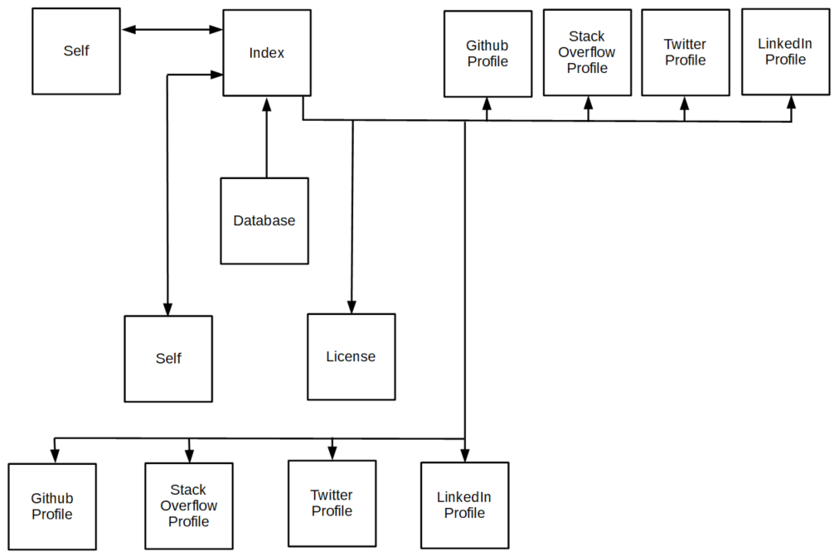
Figure 1. Index Page Flowchart

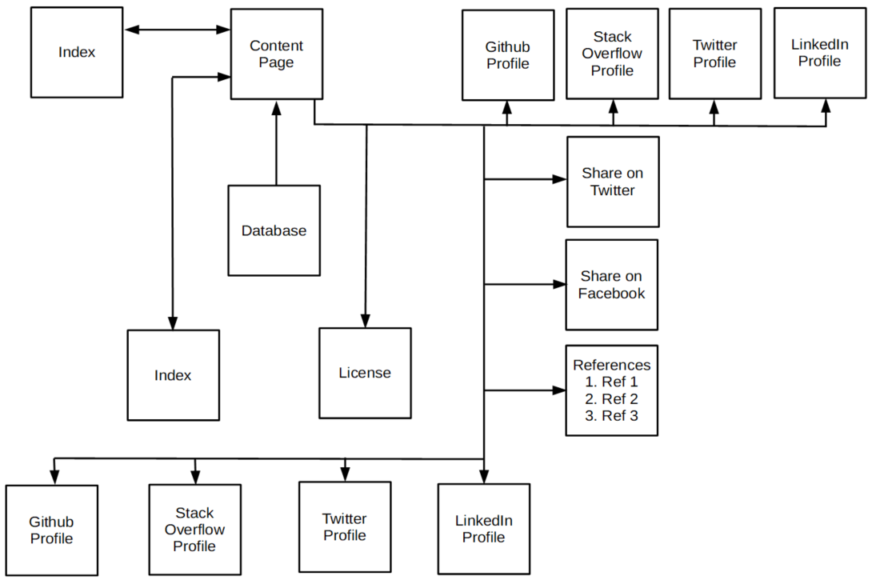
Figure 2. Content Page Flowchart

Functional Requirements
- Index
  - Link to Index page at top and bottom of page
  - Link to Github profile at top and bottom of page
  - Link to Stack Overflow profile at top and bottom of page
  - Link to Twitter profile at top and bottom of page
  - Link to LinkedIn profile at top and bottom of page
- Content
  - Link to Index page at top and bottom of page
  - Link to Github profile at top and bottom of page
  - Link to Stack Overflow profile at top and bottom of page
  - Link to Twitter profile at top and bottom of page
  - Link to LinkedIn profile at top and bottom of page
System/Software Requirements
- Internet connection
- Browser
  - Mozilla Firefox
  - Microsoft Edge
  - Opera
  - Safari
External Interface Requirements
- The following links must work:
  - Github
  - Stack Overflow
  - Twitter
  - LinkedIn

Home Page
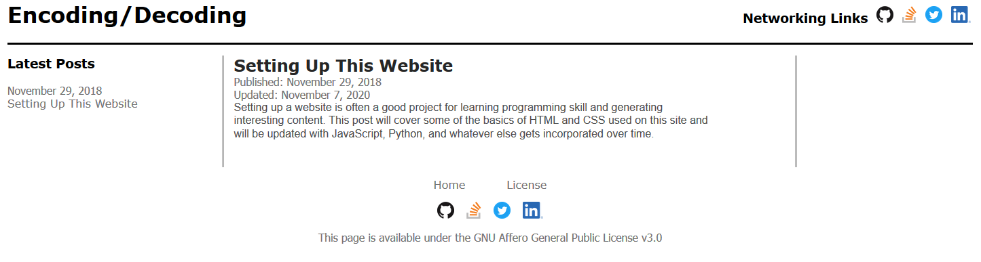
Content Page (Top)
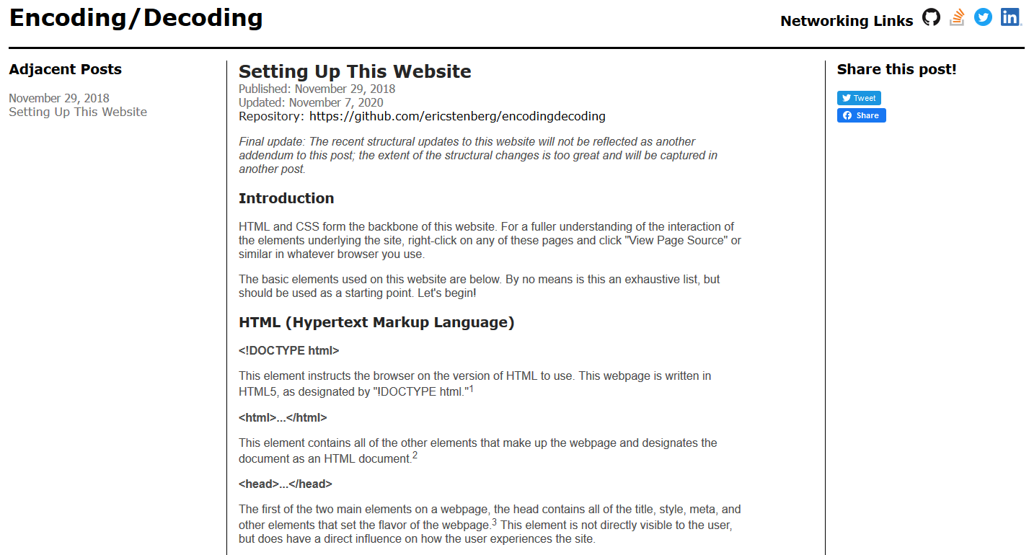

Content Page (Bottom)
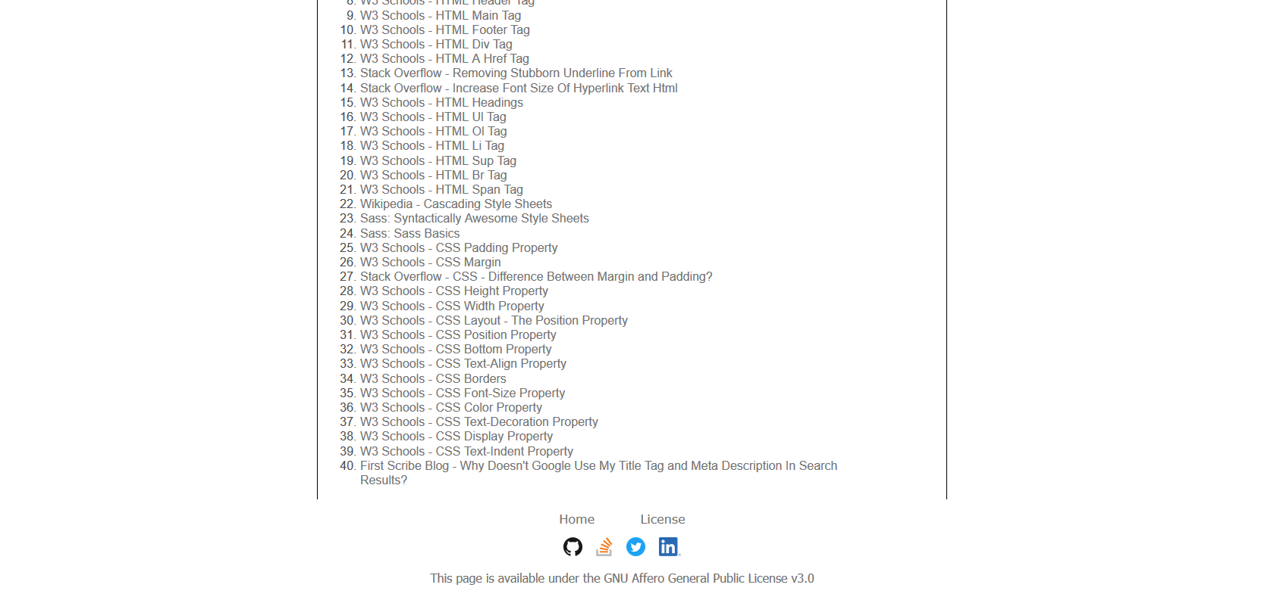
Performance Requirements
- TBD

Quality
- TBD

